**Itinerary 1: Niagara Falls**

**Profile:**

Name: Dishi

Gender: Male

Age: 27

Language: English

Active: 3(high)

**Node 1:**

Location: Niagara Falls

Season: 9

Budget: $$ (2)

Duration: 1

Style: relaxing (4)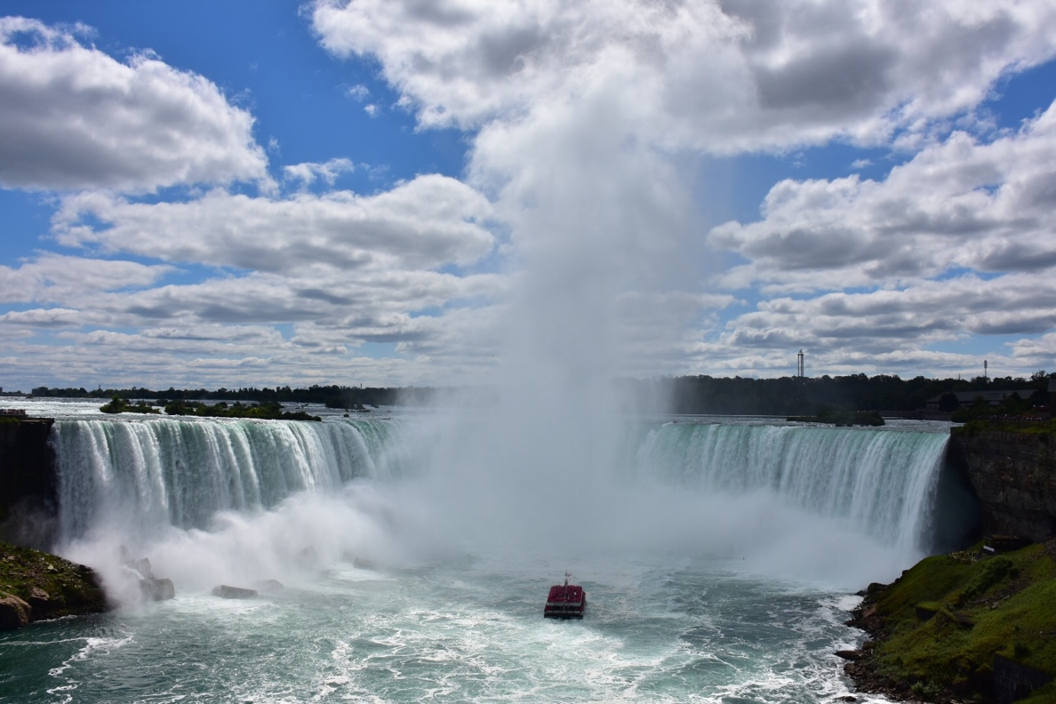

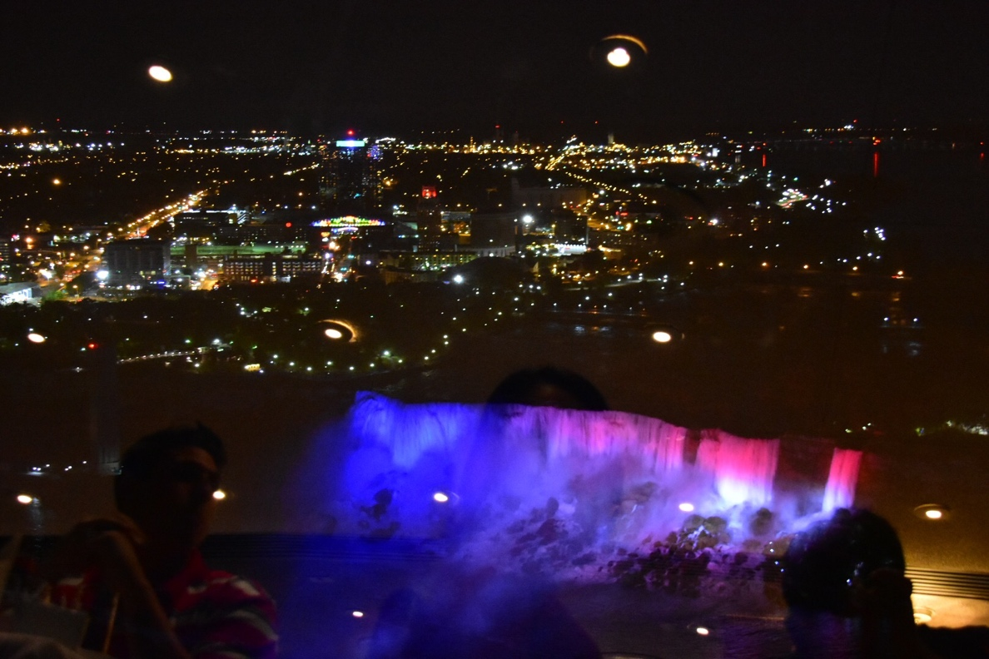

Node 2:

Location: Winery

Season: 9

Budget: $$$ (3)

Duration: 1

Style: relaxing (4)

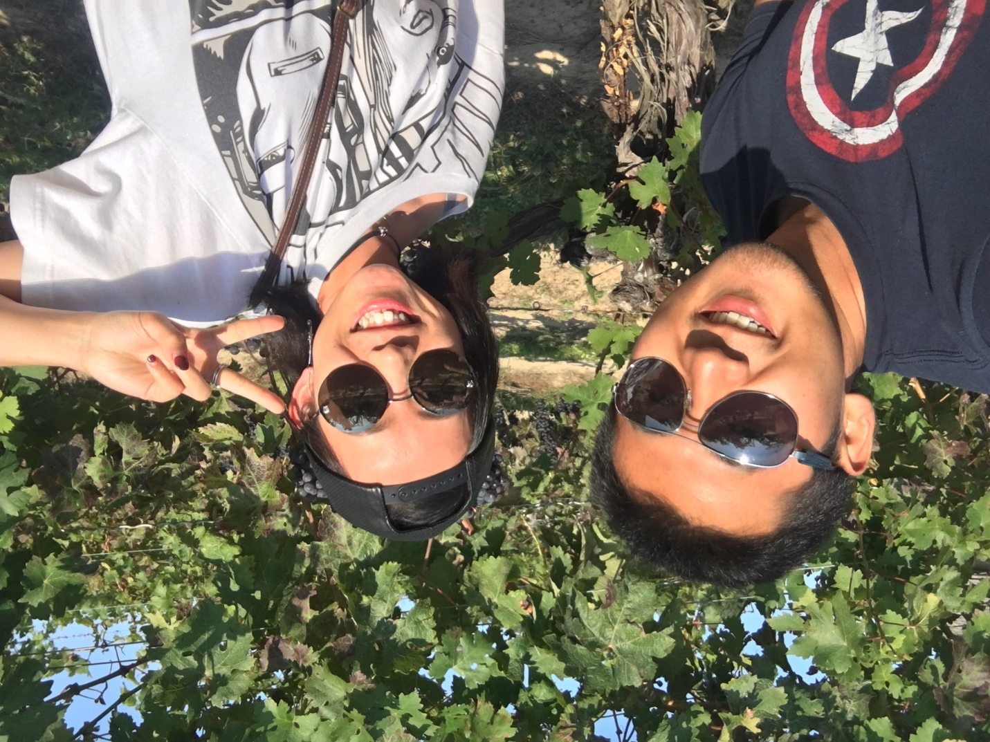

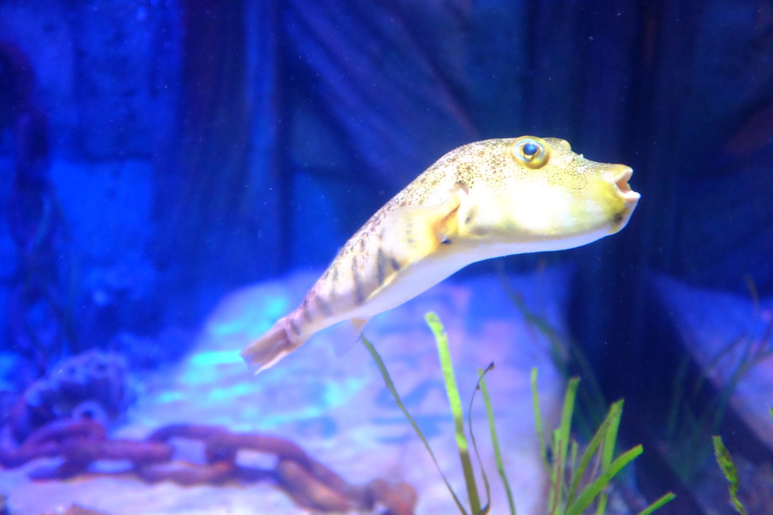

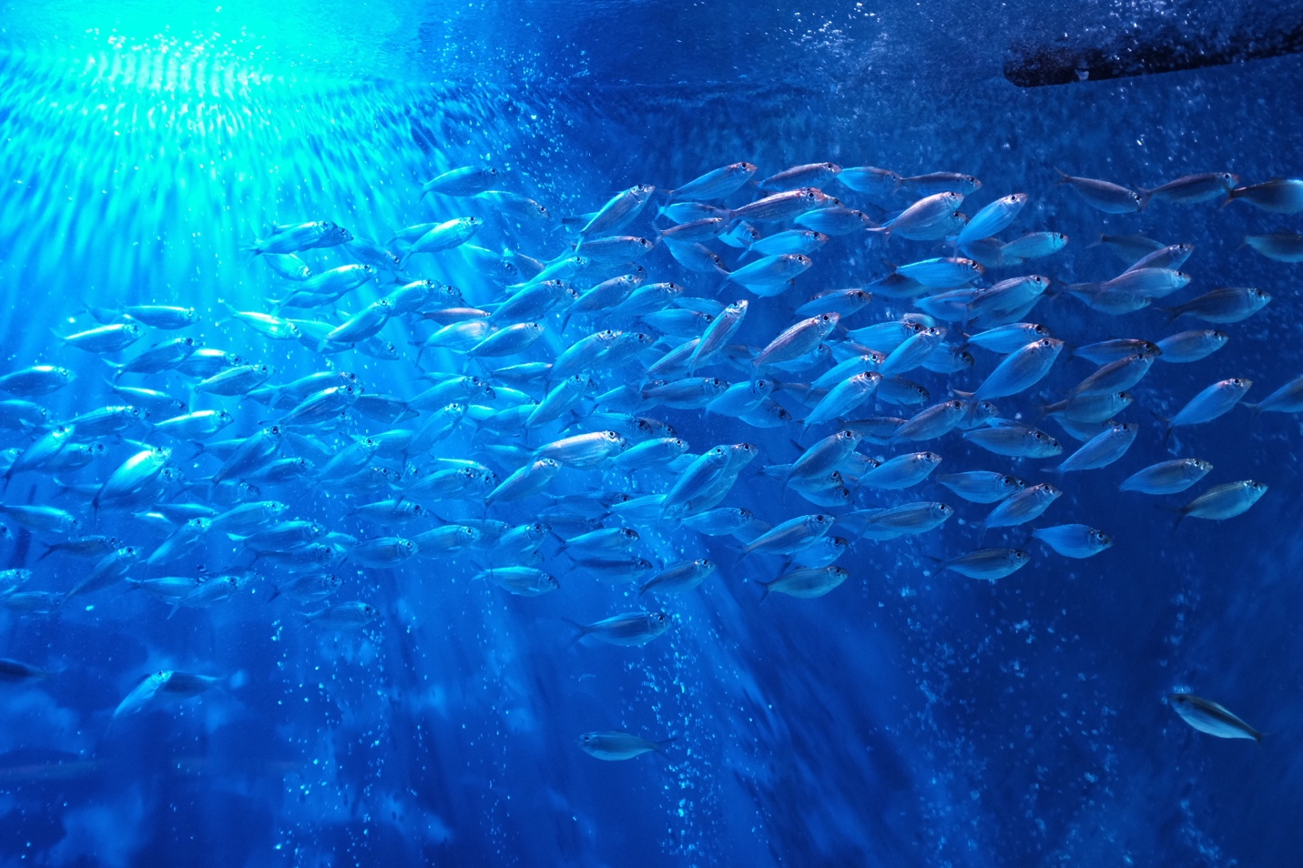

**Itinerary 2: Sea Life Michigan Aquarium**

**Profile:**

Name: Quella

Gender: Female

Age: 23

Language: English

Active: 3(high)

**Node 1:**

Location: Aquarium

Season: 9

Budget: $$ (2)

Duration: 1

Style: relaxing (4)

**Itinerary 3: Grand Rapids**

**Profile:**

Name: Quella

Gender: Female

Age: 23

Language: English

Active: 3(high)

**Node 1:**

Location: Grand Rapids Public Museum

Season: 8

Budget: $ (1)

Duration: 1

Style: culture (4)

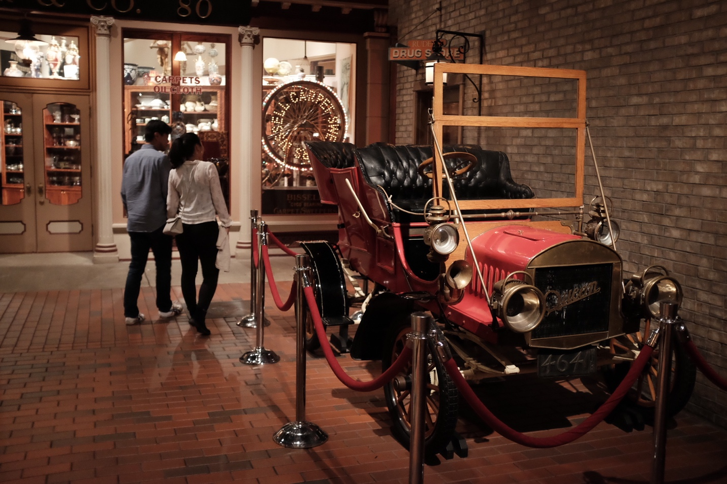

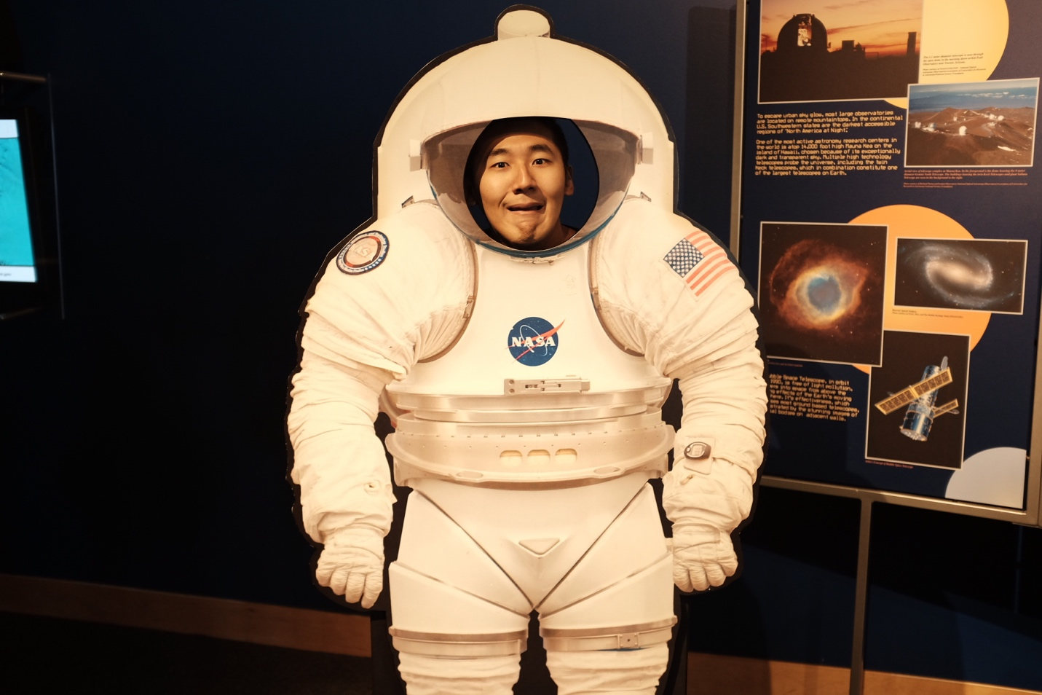

**Node 2:**

Location: John Ball Zoo

Season: 8

Budget: $$ (2)

Duration: 1

Style: relaxing (4)

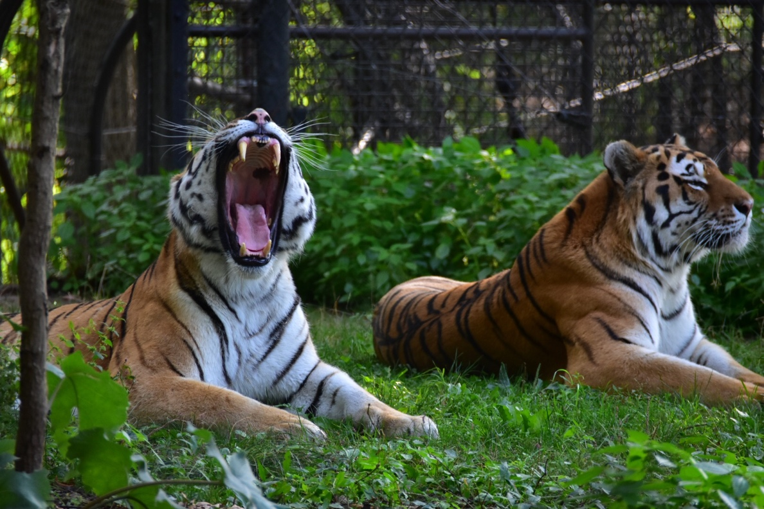

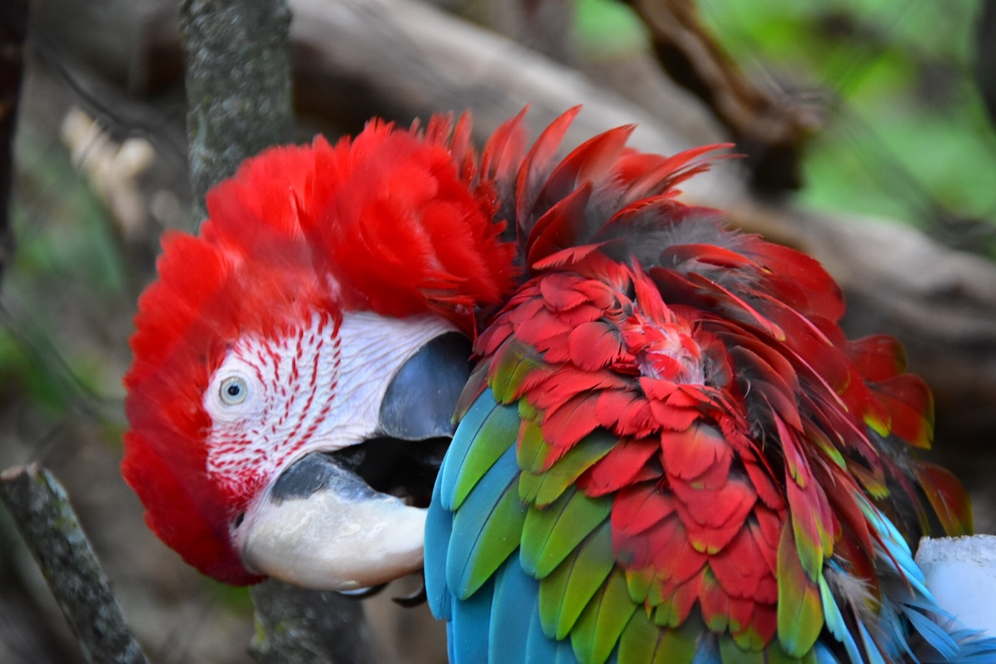

**Node 3:**

Location: Grattan Raceway

Season: 8

Budget: $$$ (3)

Duration: 1

Style: outdoor(2)

